HOMEMADE SENSORY TUNNEL

HOW TO MAKE A STRETCHY SENSORY TUNNEL FOR KIDS
To make a sensory resistance tunnel of your own, you will need:

- Spandex in the color of your choice - 3 meters long (or approximately 3 yards long) - J picked bright yellow, which is fun, but totally hard to photograph.
- Sewing machine
- Scissors
The spandex was too wide to make a good resistance tunnel. So I cut the fabric so that it was about 45 inches wide. I made my tunnel a bit roomy so that it would grow with the boys and so that it could fit an exercise ball through as well.

Once your fabric is cut to about 3 meters long x 45 inches wide, then it's time to sew. Now the sewing part is relatively easy and straightforward, but it is a lot of fabric to get through the machine - just as a FYI. Fold the fabric in half so that it makes a long rectangle (like pictured below). Use a zigzag stitch along to sew the ends of the spandex together. Don't forget to backstitch at the start and the finish. That's it! Easy, right?!

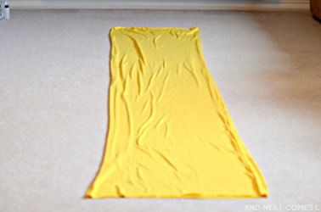

WAYS TO USE THE HOMEMADE SENSORY RESISTANCE TUNNEL
The best part about this sensory tunnel is that it is versatile. We use it for so many different activities. Obviously we use it as a tunnel, like below, but sometimes they can crawl through the tunnel while pushing an exercise ball. It's a great heavy work activity!

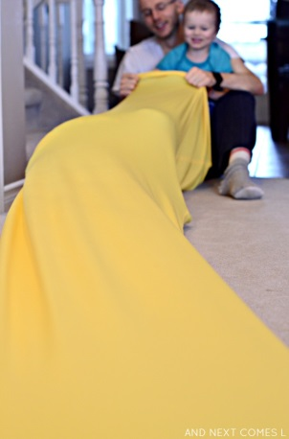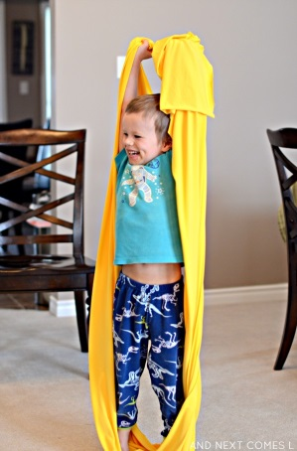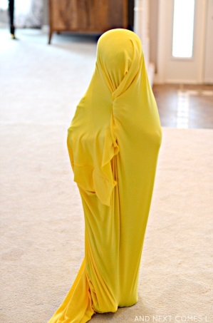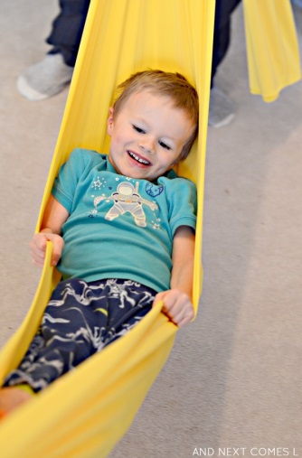

1. We also use it like stretchy resistance bands. Simply stand in the middle of the sensory tunnel, grab each end with your hands, and stretch!

2. The sensory tunnel also doubles as a body sock like this sensory sock. Just climb on in and start making shapes.

3. Wrap up like a mummy and walk around. And sometimes 2 kids can climb into different ends to make a double body sock.

4. Also use it as a sensory swing. Just grab each end of the tunnel, pick it up, and gently swing it back and forth.

And finally, here are some other suggestions:

- Play tug of war. Two people grab opposite ends of the sensory tunnel and pull back and forth
- Create a high jump or limbo bar with it. Two people hold each end, lower and raise it, while encouraging the kids to jump over, crawl under, roll under, etc. It's a great way to work on the words "over" and "under."
- If you have a smooth soft surface like some tumbling gymnastic mats, then you can have your child climb into the sensory tunnel or lay on top, then pull them across the mats. It's sort of like riding a magic carpet!

How to make a HOMEMADE STRETCHY SENSORY SHEET

Before I splurged on some fabric for making some homemade stretchy sensory sheets, I wanted to make sure my son would actually like the idea of it. I took our homemade sensory tunnel, which just happens to be the same length required to wrap around my son's mattress, and tried it as a temporary sensory sheet. It worked really great, especially during bedtime reading. Finally, my son wasn't rolling around and doing somersaults while we read together. Instead he would lay calmly underneath it.

I decided that it was worth making a trip to the fabric store and finally making a legit stretchy lycra bedsheet for him.

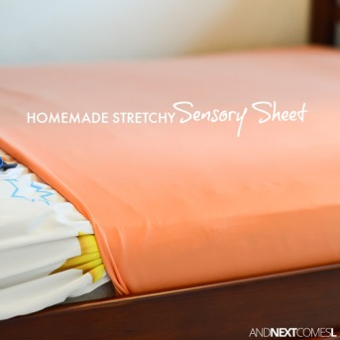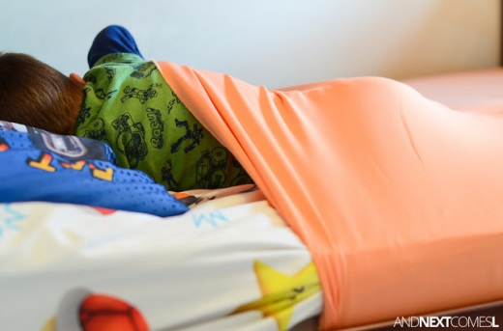

The inspiration for this project is this stretchy lycra sheet that costs $70! Thankfully, my final price tag was $15.

First, I measured the entire dimension of my son's mattress, top, bottom, and sides included (it was 120 inches). Then I converted it to metres so that I knew how much fabric to purchase. I needed the exact same amount of fabric that I used to make our sensory tunnel: 3 metres (which is about 3.3 yards).

To the fabric store to look for something in the clearance section. I was looking for stretchy and cheap. It also didn't have to be lycra as any stretchy fabric would work. I ended up searching and searching and finally found this peach cotton spandex blend for 70% off. So I paid $15 for 3 metres of fabric.

To sew the stretchy sheet, it's just like sewing the sensory tunnel or stretchy resistance bands. Take the two ends of the fabric and zig zag stitch them together to create a giant sleeve. That's it! Remember, you can use any kind of lycra or spandex material for this project as long as it's stretchy.

Slide the stretchy sheet onto the mattress. That was challenging since my son sleeps on the bottom of a bunk bed.

Then climb in underneath for a calming night of sleep!

